ZOMATO DATASET ANALYSIS

Google Colab Link - https://colab.research.google.com/drive/1OqagvBGBOTss8vu7EH3019-VV_WP-BMA?usp=sharing
OUTPUTS:
1.
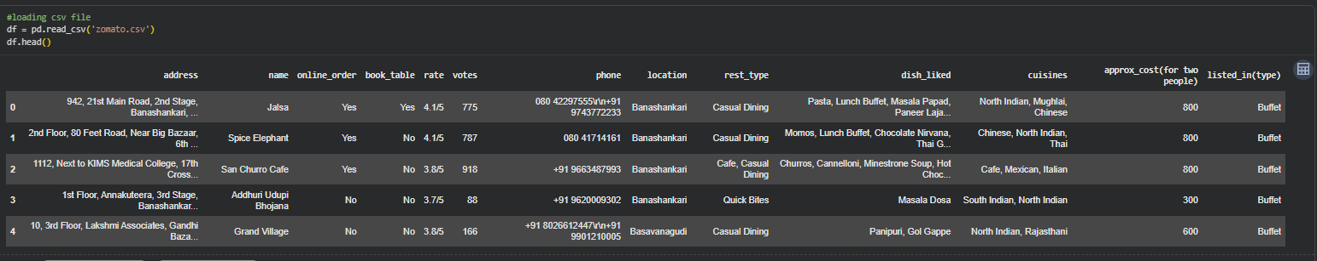
2.
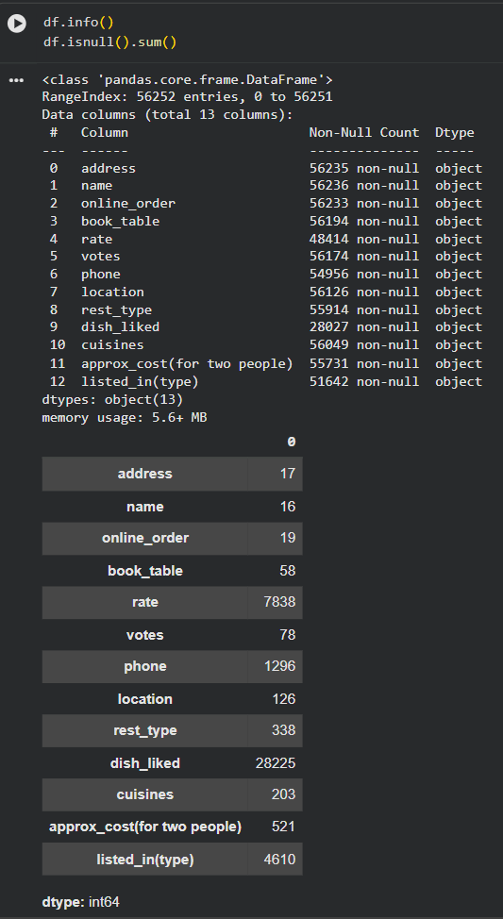
3.
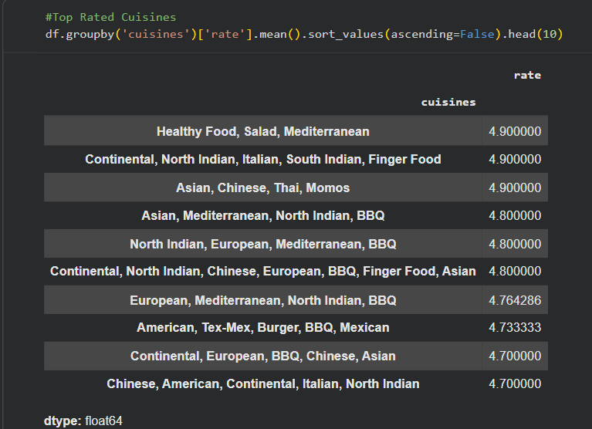
4.
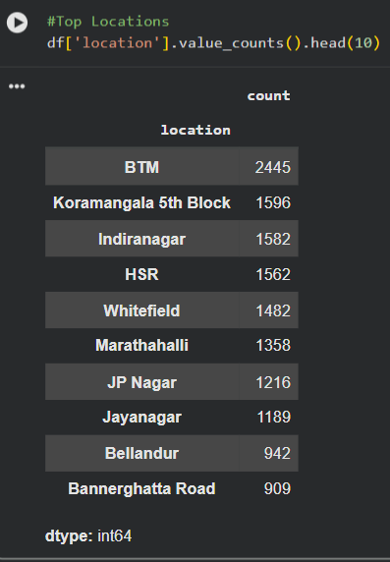
5.
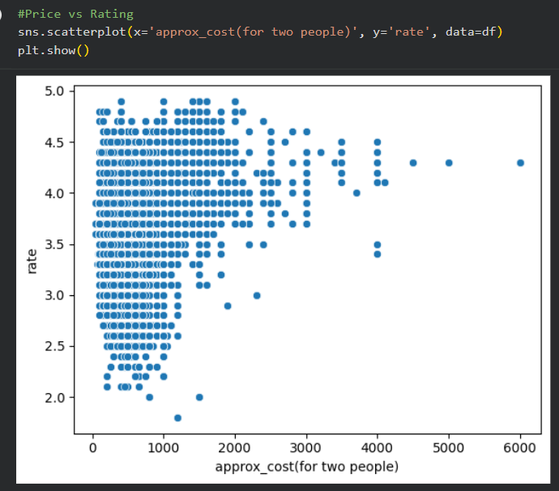
6.
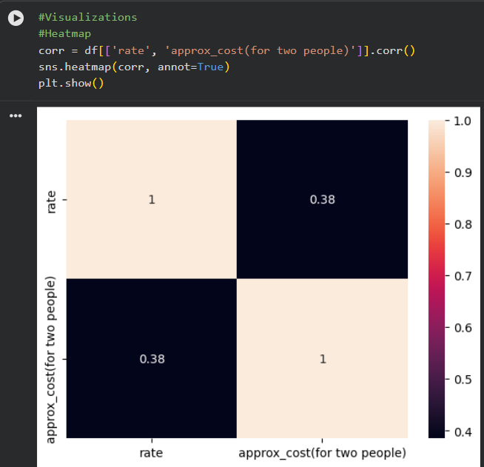
7.
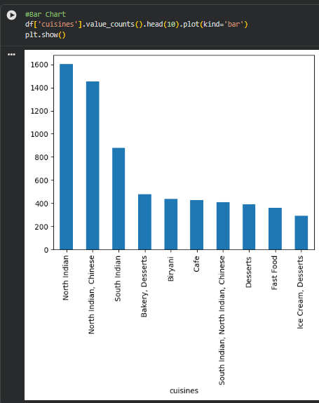
8.
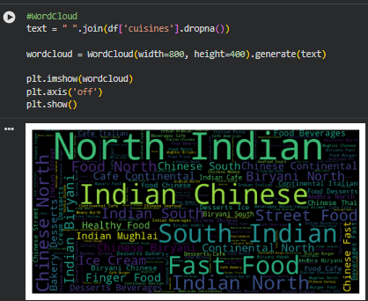

Zomato Dataset Analysis – Summary

This project focuses on analyzing the Zomato dataset to understand restaurant trends, customer preferences, and factors affecting ratings. The dataset was first cleaned by removing duplicate entries, handling missing values, and converting important columns such as ratings and cost into proper numerical formats. This step ensured that the data was accurate and ready for analysis.
After cleaning, exploratory data analysis (EDA) was performed to identify key patterns. The analysis showed that some cuisines, especially North Indian, Chinese, and South Indian, are highly popular among customers. It was also observed that certain locations like BTM, Koramangala, and Indiranagar have a high concentration of restaurants, making them important food hubs.
Further analysis revealed that there is no strong relationship between the cost of a restaurant and its rating. This means that higher-priced restaurants do not always provide better customer satisfaction. In fact, many affordable restaurants were found to have high ratings, indicating that quality food and service can be provided at lower prices as well. Additionally, most restaurant ratings fall between 3.5 and 4.5, suggesting that overall customer experiences are generally positive.
Visualizations such as bar charts, heatmaps, scatter plots, and word clouds were used to better understand and present the data. These visual tools helped in identifying trends and making the analysis more intuitive and easy to interpret.
Based on the findings, several recommendations were made. Promoting highly rated and affordable restaurants can attract more customers. Focusing on popular cuisines and high-demand locations can improve business performance. Highlighting customer reviews can help users make better decisions, while also building trust. Lastly, giving visibility to underrated but well-performing restaurants can create a more balanced and competitive platform.
Overall, this analysis provides useful insights into customer behavior and restaurant performance, which can help in making better business and marketing decisions.

